GLOBALSQA BANKING PROJECT
Exploratory Testing
Defect Report
Final testing results • Business-impact validation • Evidence-backed findings
20 | 15 | 5 | 3
Total findings | Defects | Improvements | Business rules pending

Scope and classification
This report consolidates the final exploratory-testing observations recorded against the GlobalSQA Banking application. Findings are separated into confirmed functional/security defects and usability or control improvements. Three observations retain an explicit business-rule confirmation note so the report does not overstate an assumed requirement.
Application: https://www.globalsqa.com/angularJs-protractor/BankingProject/#/login
Execution date: 30 July 2026

SECTION 01
Confirmed Defects
Functional, security, validation, and transaction-control issues observed during exploratory testing.

DEF-01 | Customer Login Does Not Require Identity Verification
SEVERITY HIGH | VALIDATION Observed during exploratory testing; evidence retained in this report.

Description: A user can select any customer from the login dropdown and access that customer's banking information without providing a password, OTP, or any other identity proof. The application should authenticate the selected customer before displaying account information.
Business impact: Unauthorised users could impersonate customers and view account information, creating a serious confidentiality and account-takeover risk.
Steps to reproduce
- Open the application link.
- Click Customer Login.
- Select any customer from the Your Name dropdown.
- Click Login.
- Observe that the customer's account page opens without any identity verification.
Expected result: The customer must provide valid authentication credentials before account information is displayed.
Actual result: Selecting a customer name is sufficient to open the account without authentication.
Application link: https://www.globalsqa.com/angularJs-protractor/BankingProject/#/login
Evidence
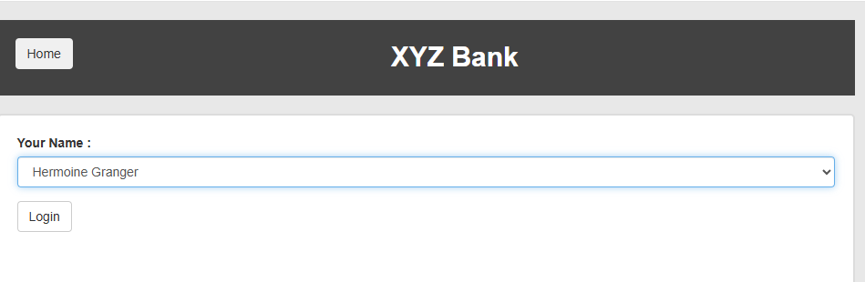
Evidence 1
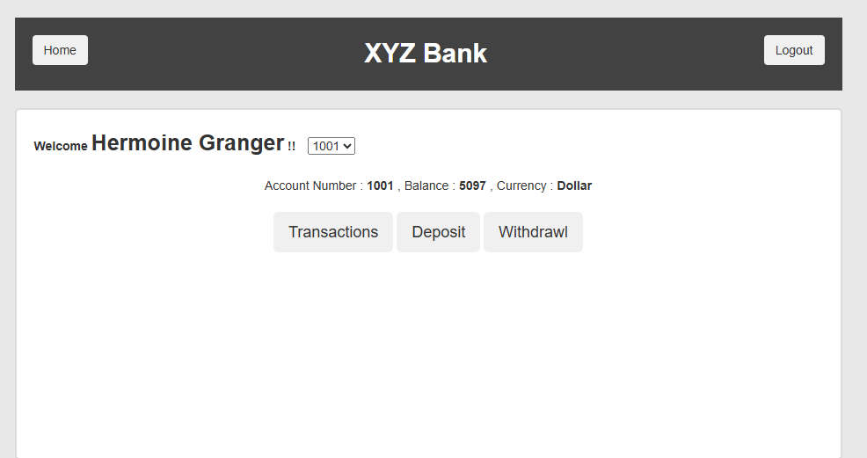
Evidence 2

DEF-02 | Bank Manager Login Does Not Require Credentials
SEVERITY CRITICAL | VALIDATION Observed during exploratory testing; evidence retained in this report.

Description: The Bank Manager area opens without requesting a username, password, or any other authorization. Administrative functions should be available only after successful authentication.
Business impact: Administrative functions are exposed without access control, allowing unauthorised creation, modification, or deletion of banking data.
Steps to reproduce
- Open the application link.
- Click Bank Manager Login.
- Observe that the manager dashboard opens immediately.
- Verify that no username, password, or authorization check is requested.
Expected result: The manager area must be protected by valid credentials and role-based authorisation.
Actual result: The Bank Manager dashboard opens without credentials or an authorisation check.
Application link: https://www.globalsqa.com/angularJs-protractor/BankingProject/#/login
Evidence
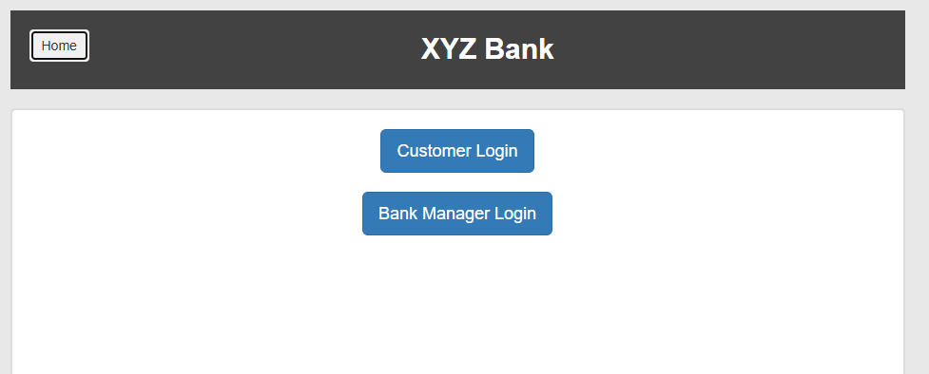
Evidence 1
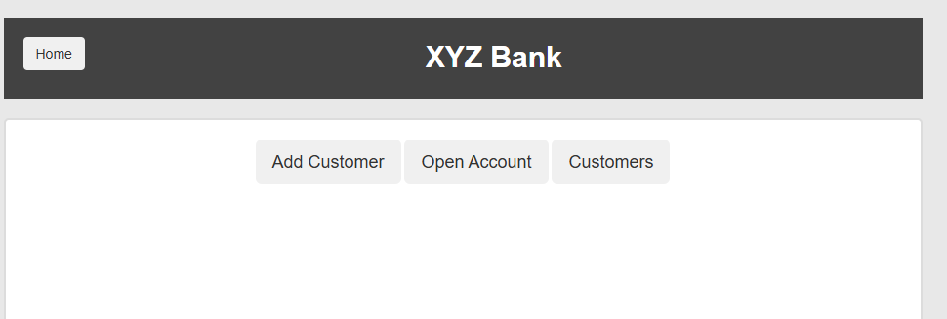
Evidence 2

DEF-03 | First Name Field Accepts Numeric Values
SEVERITY MEDIUM | VALIDATION Observed during exploratory testing; evidence retained in this report.

Description: The Add Customer form accepts a First Name containing only digits. The field should validate the permitted name format and reject unsupported numeric-only input.
Business impact: Invalid customer master data can enter the system and cause downstream search, reporting, integration, and reconciliation failures.
Steps to reproduce
- Open the application and select Bank Manager Login.
- Open the Add Customer tab.
- Enter 12345 in the First Name field.
- Enter valid values in Last Name and Post Code.
- Click Add Customer and observe that the record is accepted.
Expected result: The First Name field must reject numeric-only values and display a clear validation message.
Actual result: A numeric-only First Name is accepted.
Application link: https://www.globalsqa.com/angularJs-protractor/BankingProject/#/login
Evidence
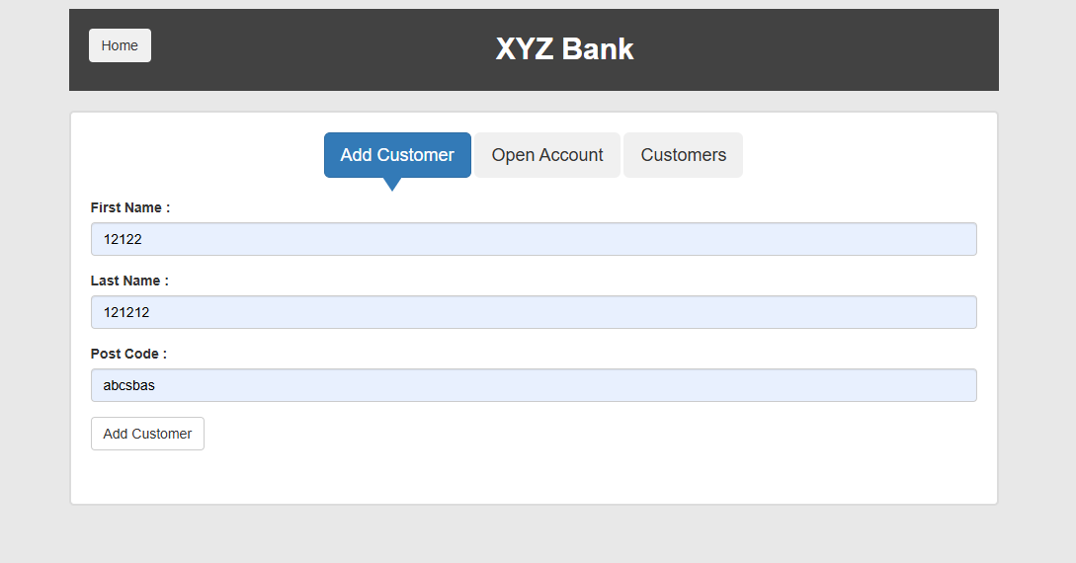
Evidence 1
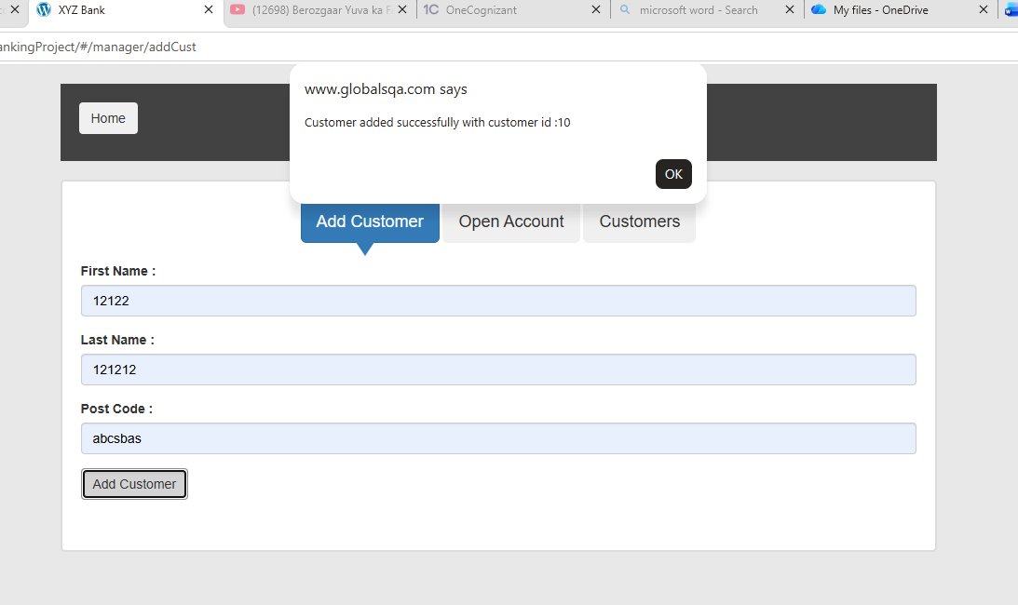
Evidence 2
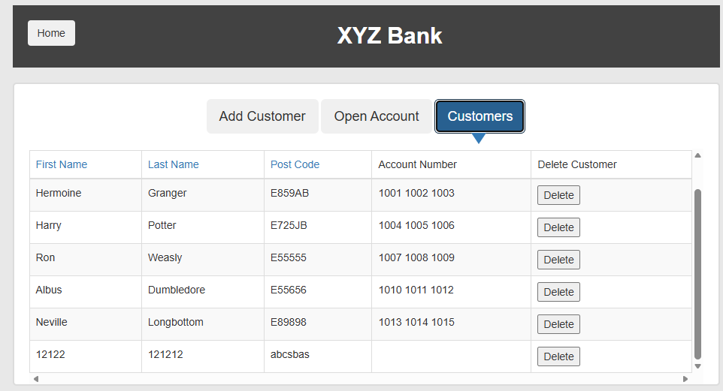
Evidence 3

DEF-04 | Last Name Field Accepts Numeric Values
SEVERITY MEDIUM | VALIDATION Observed during exploratory testing; evidence retained in this report.

Description: The Add Customer form accepts a Last Name containing only digits. The field should validate the permitted name format and reject unsupported numeric-only input.
Business impact: Invalid customer master data can enter the system and cause downstream search, reporting, integration, and reconciliation failures.
Steps to reproduce
- Open Bank Manager Login and select Add Customer.
- Enter a valid First Name.
- Enter 12345 in the Last Name field.
- Enter a valid Post Code.
- Click Add Customer and observe that the record is accepted.
Expected result: The Last Name field must reject numeric-only values and display a clear validation message.
Actual result: A numeric-only Last Name is accepted.
Application link: https://www.globalsqa.com/angularJs-protractor/BankingProject/#/login
Evidence

Evidence 1

Evidence 2

Evidence 3

DEF-05 | First Name Field Accepts Unsupported Special Characters
SEVERITY MEDIUM | VALIDATION Observed during exploratory testing; evidence retained in this report.

Description: The First Name field accepts unsupported special-character-only input. The application should enforce the approved customer-name character set.
Business impact: Unsupported characters can reduce data quality and cause failures in downstream systems that expect a controlled customer-name format.
Steps to reproduce
- Open Bank Manager Login and select Add Customer.
- Enter @#$% in the First Name field.
- Enter valid values in Last Name and Post Code.
- Click Add Customer.
- Observe that the customer record is accepted without a validation message.
Expected result: The First Name field must enforce the approved character set and reject unsupported special-character-only input.
Actual result: A special-character-only First Name is accepted.
Application link: https://www.globalsqa.com/angularJs-protractor/BankingProject/#/login
Evidence
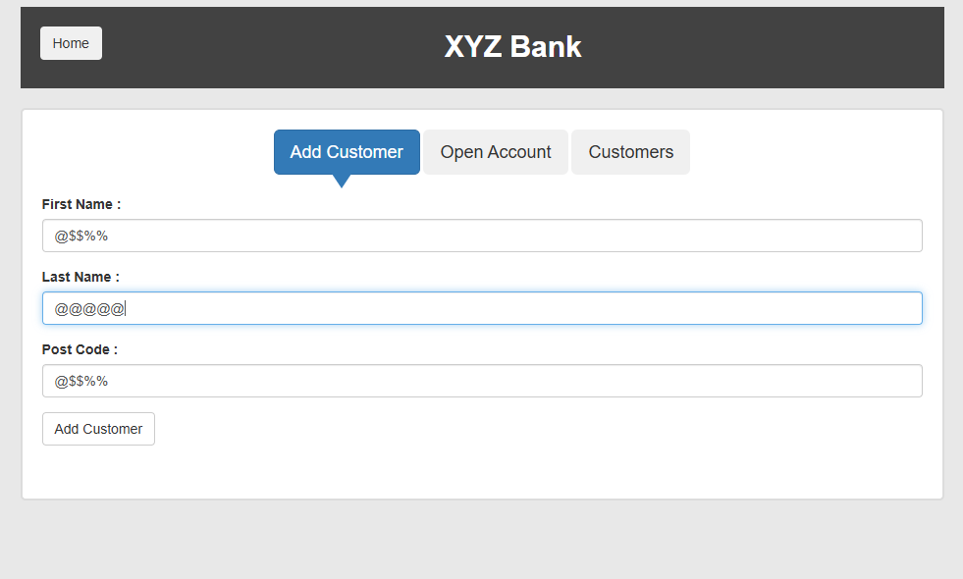
Evidence 1
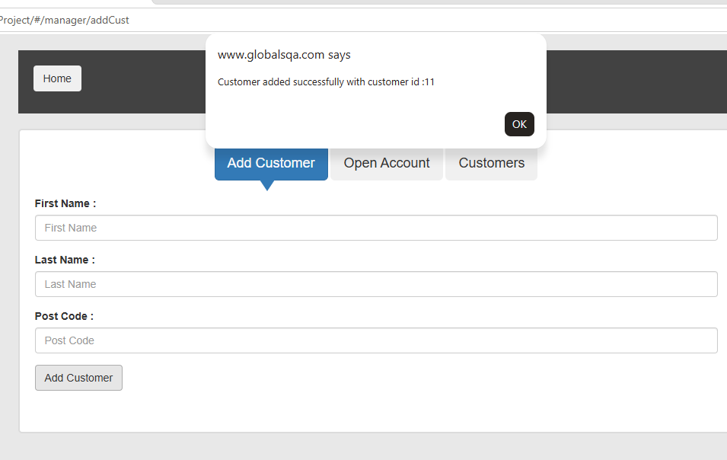
Evidence 2
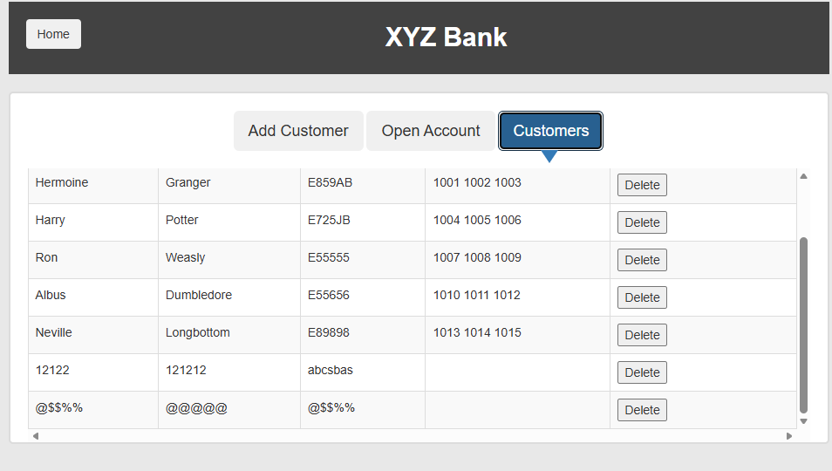
Evidence 3

DEF-06 | Last Name Field Accepts Unsupported Special Characters
SEVERITY MEDIUM | VALIDATION Observed during exploratory testing; evidence retained in this report.

Description: The Last Name field accepts unsupported special-character-only input. The application should enforce the approved customer-name character set.
Business impact: Unsupported characters can reduce data quality and cause failures in downstream systems that expect a controlled customer-name format.
Steps to reproduce
- Open Bank Manager Login and select Add Customer.
- Enter a valid First Name.
- Enter @#$% in the Last Name field.
- Enter a valid Post Code.
- Click Add Customer and observe that the record is accepted.
Expected result: The Last Name field must enforce the approved character set and reject unsupported special-character-only input.
Actual result: A special-character-only Last Name is accepted.
Application link: https://www.globalsqa.com/angularJs-protractor/BankingProject/#/login
Evidence

Evidence 1

Evidence 2

Evidence 3

DEF-07 | Inappropriate error for using Only Blank Spaces in First Name
SEVERITY HIGH | VALIDATION Observed during exploratory testing; evidence retained in this report.

Description: The First Name field treats whitespace as valid content and permits a customer record with no meaningful first name. Whitespace-only values should be trimmed and rejected.
Business impact: Blank customer names create unusable or duplicate-looking records and make identification, search, and audit activities unreliable.
Steps to reproduce
- Open Bank Manager Login and select Add Customer.
- Enter one or more spaces in the First Name field.
- Enter valid values in Last Name and Post Code.
- Click Add Customer.
- Observe that the whitespace-only First Name is accepted.
Expected result: Whitespace must be trimmed, and an empty First Name must be rejected with a clear validation message.
Actual result: Whitespace-only input is accepted as the First Name.
Application link: https://www.globalsqa.com/angularJs-protractor/BankingProject/#/login
Evidence
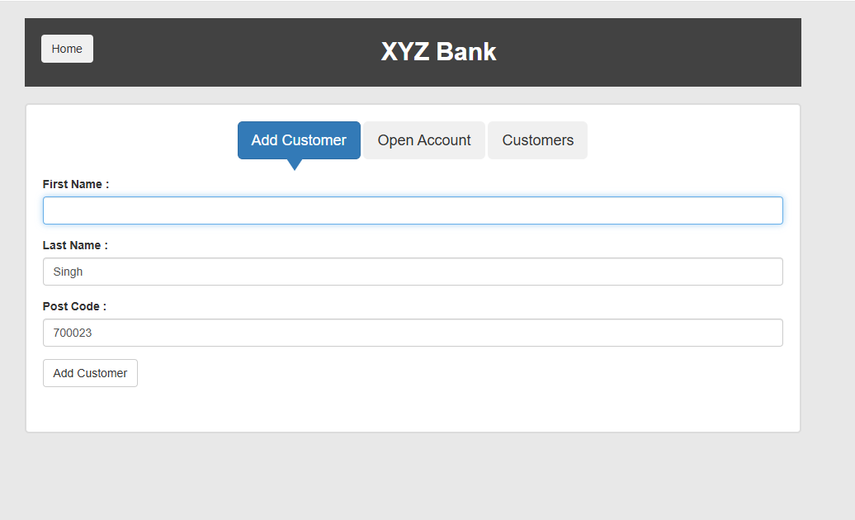
Evidence 1
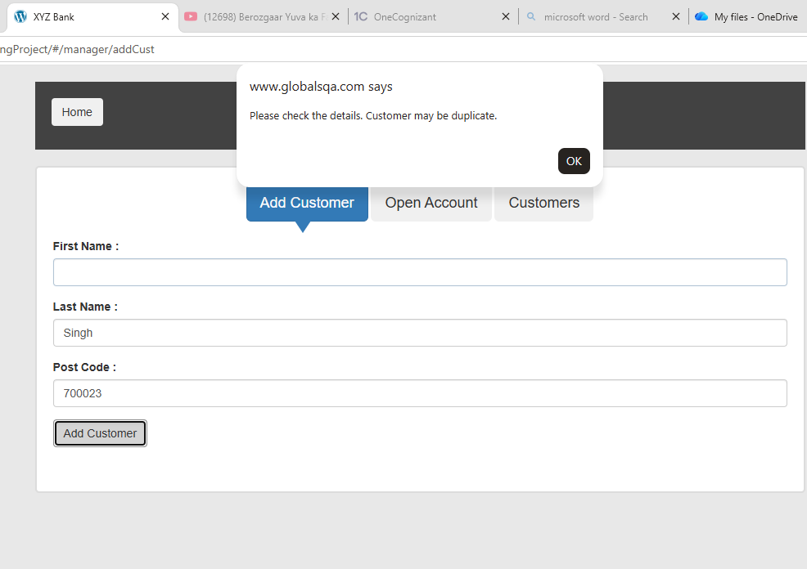
Evidence 2

DEF-08 | Post Code Field Accepts Alphabetic Values Without Validation
SEVERITY MEDIUM | VALIDATION Observed; supported postal-code format requires business-rule confirmation.

Description: The Post Code field accepts alphabetic input without applying a defined postal-code format rule. The application should validate the field against the supported country or business format.
Business impact: If the supported postal-code format excludes unrestricted alphabetic values, invalid address data may affect onboarding, correspondence, and downstream validation.
Steps to reproduce
- Open Bank Manager Login and select Add Customer.
- Enter valid First Name and Last Name values.
- Enter alphabetic text such as ABCDE in the Post Code field.
- Click Add Customer.
- Observe that the value is accepted without format validation.
Expected result: The Post Code field must validate input against the formally supported postal-code rules.
Actual result: Alphabetic Post Code input is accepted without a defined format validation message.
Business-validation note: Confirm the applicable product rule with the business owner before treating this finding as a release-blocking defect.
Application link: https://www.globalsqa.com/angularJs-protractor/BankingProject/#/login
Evidence

Evidence 1

Evidence 2

Evidence 3

DEF-09 | Post Code Field Accepts Unsupported Special Characters
SEVERITY MEDIUM | VALIDATION Observed during exploratory testing; evidence retained in this report.

Description: The Post Code field accepts unsupported special-character-only input. The field should enforce the approved postal-code character set and format.
Business impact: Invalid postal-code characters can corrupt address data and cause failures in onboarding, correspondence, reporting, or downstream integrations.
Steps to reproduce
- Open Bank Manager Login and select Add Customer.
- Enter valid First Name and Last Name values.
- Enter @#$% in the Post Code field.
- Click Add Customer.
- Observe that the invalid value is accepted.
Expected result: The Post Code field must reject unsupported special-character-only input.
Actual result: Unsupported special-character-only Post Code input is accepted.
Application link: https://www.globalsqa.com/angularJs-protractor/BankingProject/#/login
Evidence

Evidence 1

Evidence 2

Evidence 3

DEF-10 | First Name Field Accepts Excessively Long Values
SEVERITY MEDIUM | VALIDATION Observed during exploratory testing; evidence retained in this report.

Description: The First Name field does not enforce a reasonable maximum length. Oversized input should be prevented or rejected according to the customer-data specification.
Business impact: Oversized names can damage page layouts, exceed downstream field limits, and cause data truncation or integration failures.
Steps to reproduce
- Open Bank Manager Login and select Add Customer.
- Paste a First Name containing at least 256 characters.
- Enter valid Last Name and Post Code values.
- Click Add Customer.
- Observe that the oversized value is accepted or affects the page layout.
Expected result: The First Name field must enforce the approved maximum length without breaking the interface.
Actual result: An excessively long First Name is accepted or affects the interface layout.
Application link: https://www.globalsqa.com/angularJs-protractor/BankingProject/#/login
Evidence
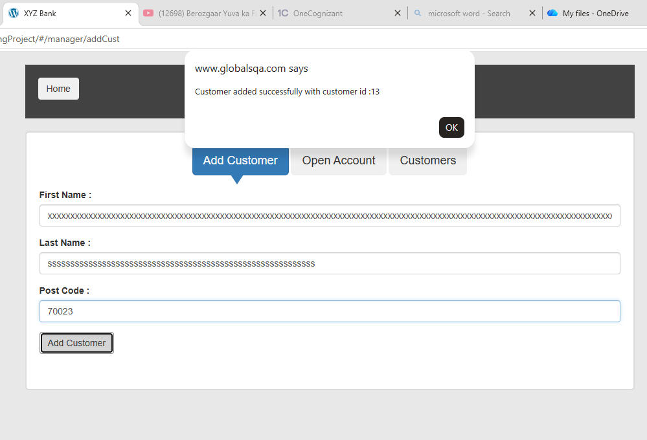
Evidence 1
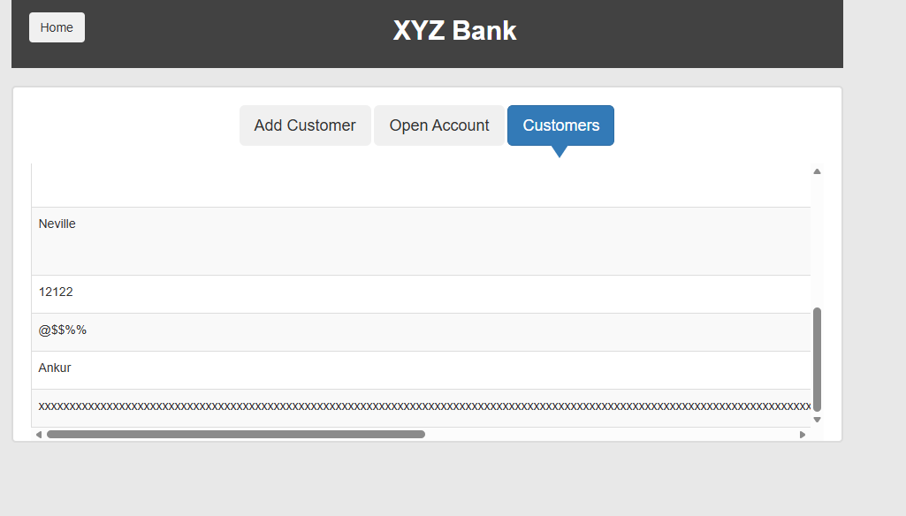
Evidence 2

DEF-11 | Last Name Field Accepts Excessively Long Values
SEVERITY MEDIUM | VALIDATION Observed during exploratory testing; evidence retained in this report.

Description: The Last Name field does not enforce a reasonable maximum length. Oversized input should be prevented or rejected according to the customer-data specification.
Business impact: Oversized names can damage page layouts, exceed downstream field limits, and cause data truncation or integration failures.
Steps to reproduce
- Open Bank Manager Login and select Add Customer.
- Enter a valid First Name.
- Paste a Last Name containing at least 256 characters.
- Enter a valid Post Code and click Add Customer.
- Observe that the oversized value is accepted or affects the page layout.
Expected result: The Last Name field must enforce the approved maximum length without breaking the interface.
Actual result: An excessively long Last Name is accepted or affects the interface layout.
Application link: https://www.globalsqa.com/angularJs-protractor/BankingProject/#/login
Evidence

Evidence 1

Evidence 2

DEF-12 | Post Code Field Accepts Excessively Long Values
SEVERITY MEDIUM | VALIDATION Observed during exploratory testing; evidence retained in this report.

Description: The Post Code field does not enforce a reasonable maximum length. Oversized postal-code input should be prevented or rejected.
Business impact: Oversized postal codes can exceed downstream field limits and create truncation, address-validation, or integration failures.
Steps to reproduce
- Open Bank Manager Login and select Add Customer.
- Enter valid First Name and Last Name values.
- Paste a Post Code containing at least 256 characters.
- Click Add Customer.
- Observe that the oversized value is accepted or affects the page layout.
Expected result: The Post Code field must enforce the approved maximum length.
Actual result: An excessively long Post Code is accepted.
Application link: https://www.globalsqa.com/angularJs-protractor/BankingProject/#/login
Evidence
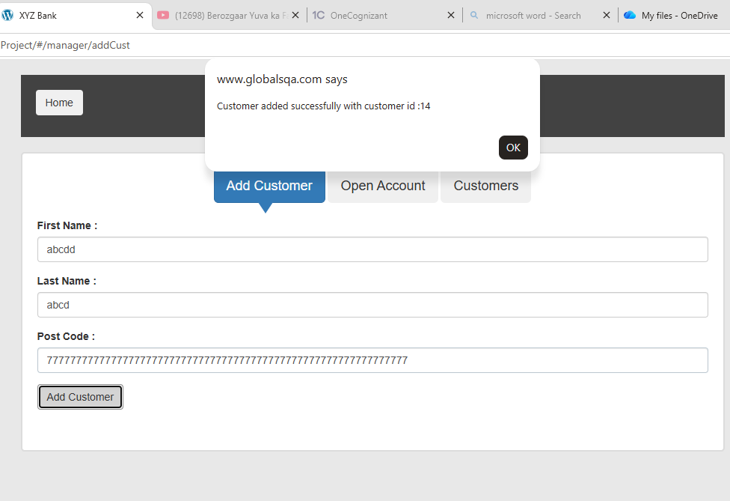
Evidence 1
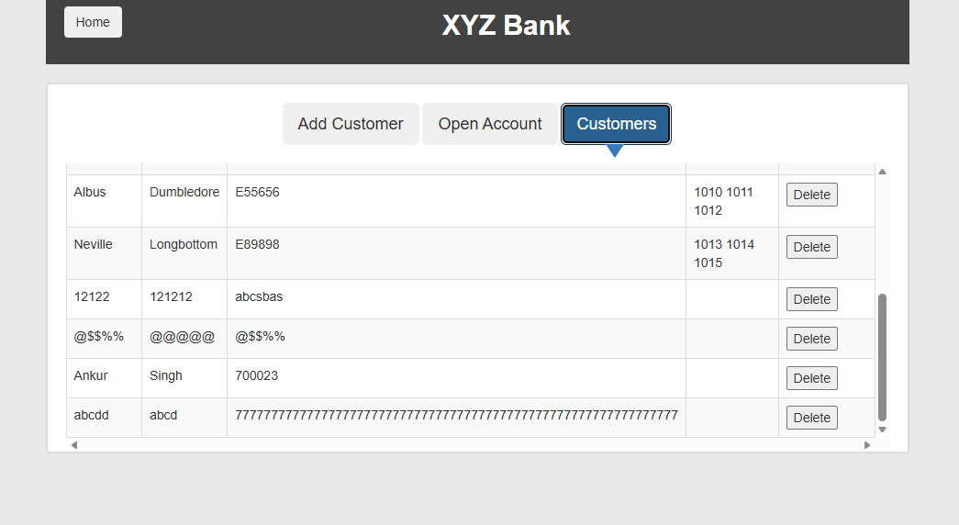
Evidence 2

DEF-13 | Multiple Accounts With the Same Currency Can Be Opened for One Customer
SEVERITY HIGH | VALIDATION Observed; duplicate-account policy requires business-rule confirmation.

Description: A manager can open the same currency account repeatedly for one customer without a duplicate-account warning or an explicit business-rule check.
Business impact: If one active account per customer and currency is the intended rule, duplicates can confuse balances, reconciliation, statements, and account servicing.
Steps to reproduce
- Open Bank Manager Login and select Open Account.
- Select a customer and a currency, then click Process.
- Dismiss the confirmation and repeat the process with the same customer and currency.
- Log in as the customer or review the customer record.
- Observe multiple accounts with the same currency.
Expected result: The application must enforce the approved customer-and-currency account rule or clearly warn the manager before creating a duplicate.
Actual result: The same currency account can be opened repeatedly for one customer without a warning.
Business-validation note: Confirm the applicable product rule with the business owner before treating this finding as a release-blocking defect.
Application link: https://www.globalsqa.com/angularJs-protractor/BankingProject/#/login
Evidence
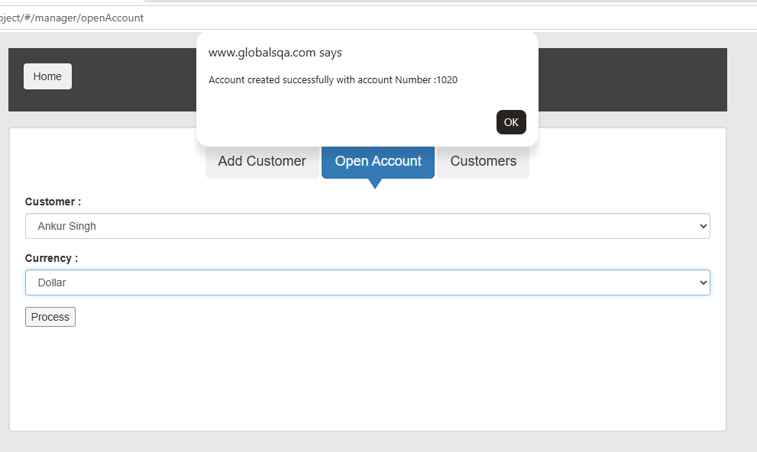
Evidence 1
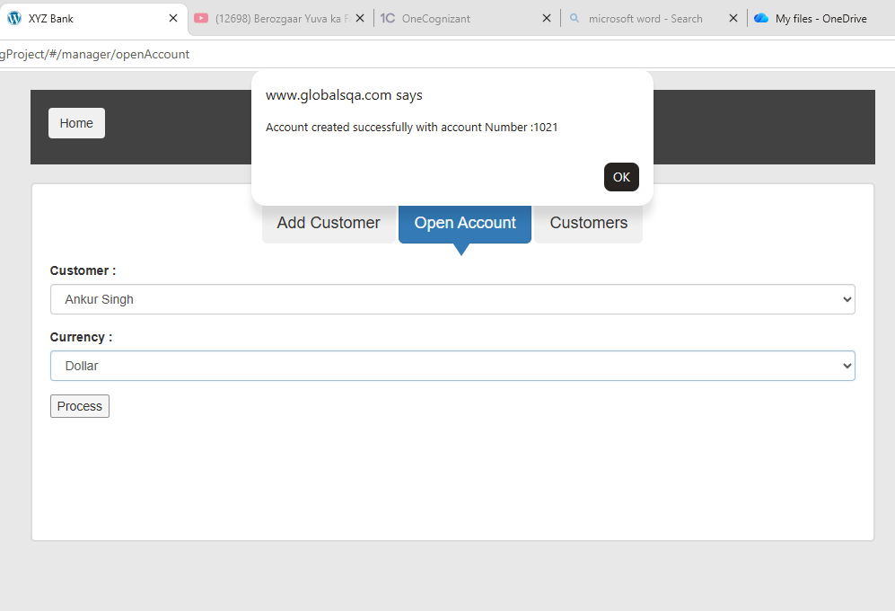
Evidence 2
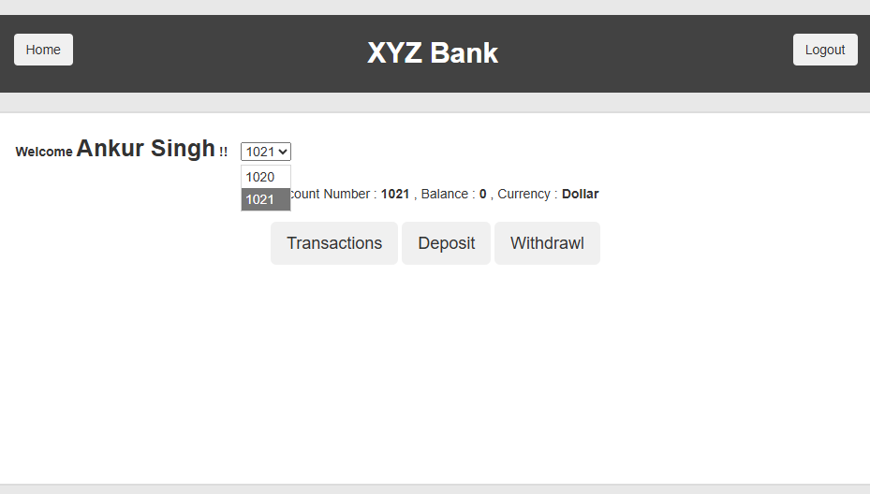
Evidence 3

DEF-14 | Deposit Field does not Accepts Decimal Values
SEVERITY MEDIUM | VALIDATION Observed during exploratory testing; evidence retained in this report.

Description: The Deposit field doesnot accepts decimal amounts , not allowing the user to perform transcation in decimals
Business impact: Whole-number-only processing prevents legitimate currency transactions that require minor units such as cents.
Steps to reproduce
- Log in as a customer and select an account.
- Open the Deposit tab.
- Enter a decimal amount with more than two decimal places, such as 10.999.
- Click Deposit.
- Observe the accepted amount and resulting balance for rounding or precision inconsistencies.
Expected result: The application must accept valid monetary values using the supported currency precision.
Actual result: A valid decimal transaction amount is not accepted.
Application link: https://www.globalsqa.com/angularJs-protractor/BankingProject/#/login
Evidence
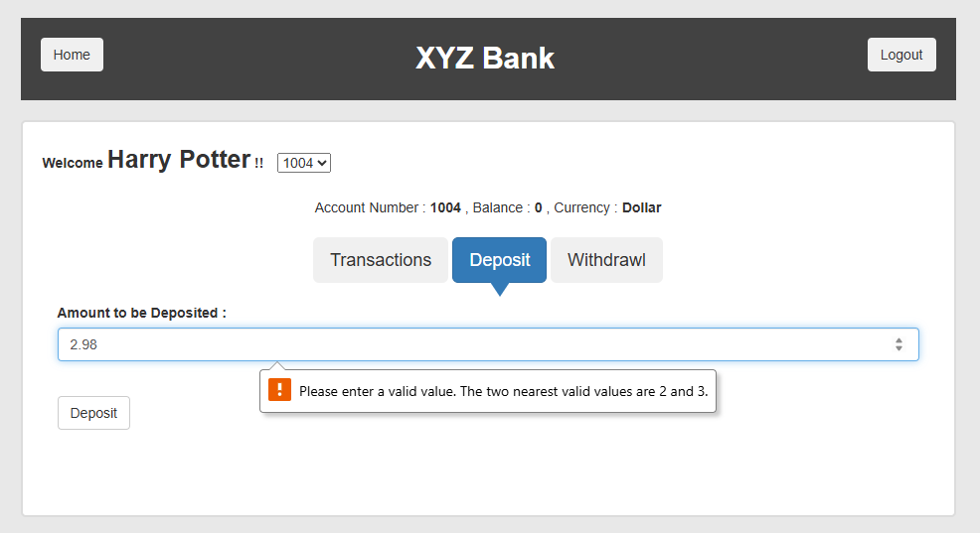
Evidence 1

DEF-15 | Deposit Field Accepts Excessively Large Amounts
SEVERITY HIGH | VALIDATION Observed; maximum transaction threshold requires business-rule confirmation.

Description: The Deposit field does not apply a visible maximum transaction limit and accepts unrealistically large values. The application should enforce configured monetary and risk-control limits.
Business impact: Without configured transaction limits, unrealistic amounts may bypass operational, fraud, or risk controls and distort account balances.
Steps to reproduce
- Log in as a customer and select an account.
- Open the Deposit tab.
- Enter an extremely large amount.
- Click Deposit.
- Observe whether the transaction is processed without a maximum-limit validation message.
Expected result: The application must enforce configured transaction and numeric-range limits and display a clear validation message.
Actual result: An unrealistically large deposit can be submitted without a visible maximum-limit validation.
Business-validation note: Confirm the applicable product rule with the business owner before treating this finding as a release-blocking defect.
Application link: https://www.globalsqa.com/angularJs-protractor/BankingProject/#/login
Evidence
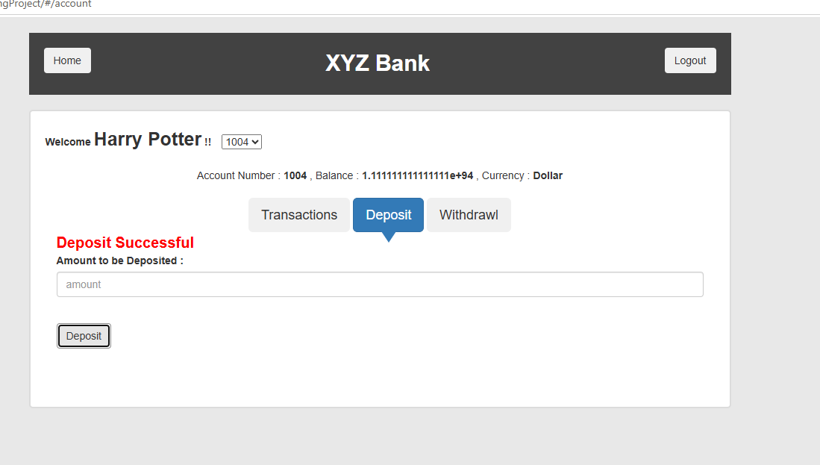
Evidence 1

SECTION 02
UI/UX & Control Improvements
Findings that improve clarity, recovery, transparency, or user confidence without overstating an unconfirmed functional requirement.

IMP-01 | Customer Is Deleted Without a Confirmation Prompt
SEVERITY HIGH | VALIDATION Observed during exploratory testing; evidence retained in this report.

Description: Selecting Delete immediately removes the customer without asking the manager to confirm the destructive action. A clear confirmation should identify the affected customer before deletion.
Business impact: A single accidental click can permanently remove a customer record, creating avoidable data-loss and operational-recovery risk.
Steps to reproduce
- Open Bank Manager Login and select Customers.
- Locate any customer record.
- Click Delete.
- Observe that no confirmation prompt is displayed.
- Verify that the customer record is removed immediately.
Expected result: The application should request confirmation and identify the affected customer before deletion.
Actual result: The customer is removed immediately when Delete is selected.
Application link: https://www.globalsqa.com/angularJs-protractor/BankingProject/#/login

IMP-02 | Customer Search Does Not Display a Clear No-Records Message
SEVERITY LOW | VALIDATION Observed during exploratory testing; evidence retained in this report.

Description: When search criteria return no matches, the table becomes empty without a clear no-records message. The interface should explicitly state that no matching customers were found.
Business impact: Users may interpret an empty table as a loading or application failure, increasing confusion and unnecessary support queries.
Steps to reproduce
- Open Bank Manager Login and select Customers.
- Enter a search value that does not match any customer.
- Review the customer table.
- Observe that the table is empty.
- Verify that no clear No records found message is displayed.
Expected result: The table should display a clear “No matching customers found” state.
Actual result: The table becomes empty without an explicit no-results message.
Application link: https://www.globalsqa.com/angularJs-protractor/BankingProject/#/login
Evidence
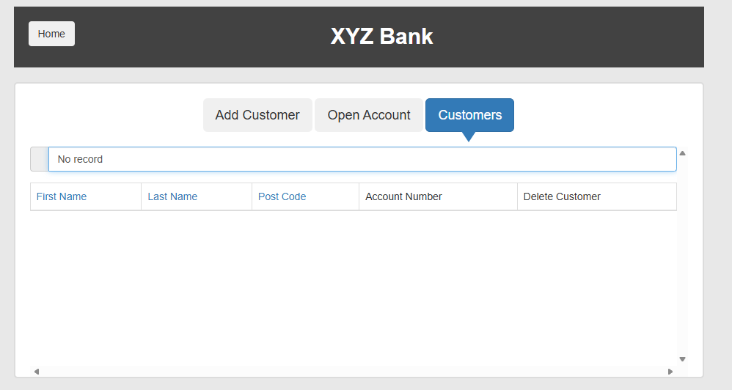
Evidence 1

IMP-03 | Insufficient-Funds Message Omits Available or Permitted Amount
SEVERITY MEDIUM | VALIDATION Observed during exploratory testing; evidence retained in this report.

Description: When a withdrawal exceeds the balance, the failure message does not provide the available balance or permitted withdrawal amount. A useful validation message should help the customer correct the transaction.
Business impact: Customers receive insufficient guidance to correct a failed withdrawal, increasing repeated attempts, frustration, and support demand.
Steps to reproduce
- Log in as a customer and select an account.
- Note the displayed account balance.
- Open the Withdrawl tab.
- Enter an amount greater than the available balance and submit.
- Observe that the failure message does not state the available or permitted amount.
Expected result: The message should clearly state the available balance or permitted withdrawal amount.
Actual result: The insufficient-funds message does not state the available or permitted amount.
Application link: https://www.globalsqa.com/angularJs-protractor/BankingProject/#/login
Evidence
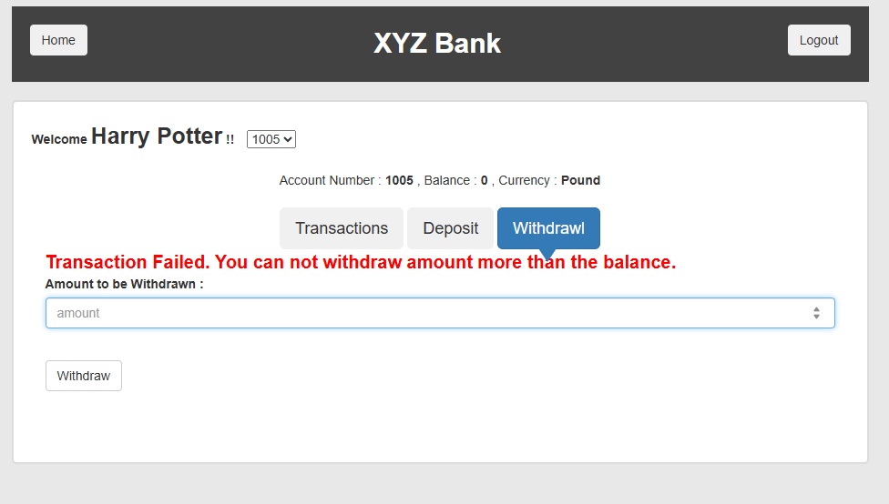
Evidence 1

IMP-04 | Transaction History Does Not Display the Running Balance
SEVERITY MEDIUM | VALIDATION Observed during exploratory testing; evidence retained in this report.

Description: The Transactions page lists the transaction date, amount, and type but does not show the balance after each transaction. A running-balance column would make reconciliation and customer support investigation clearer.
Business impact: Customers and support teams cannot easily reconcile how each transaction changed the balance, reducing transparency and auditability.
Steps to reproduce
- Log in as a customer and select an account with multiple transactions.
- Click Transactions.
- Review the transaction-history columns.
- Compare the listed transactions with the current account balance.
- Observe that no running balance is shown for individual transactions.
Expected result: Transaction history should show the balance after each transaction or provide an equivalent reconciliation view.
Actual result: The transaction table does not display a running balance.
Application link: https://www.globalsqa.com/angularJs-protractor/BankingProject/#/login
Evidence
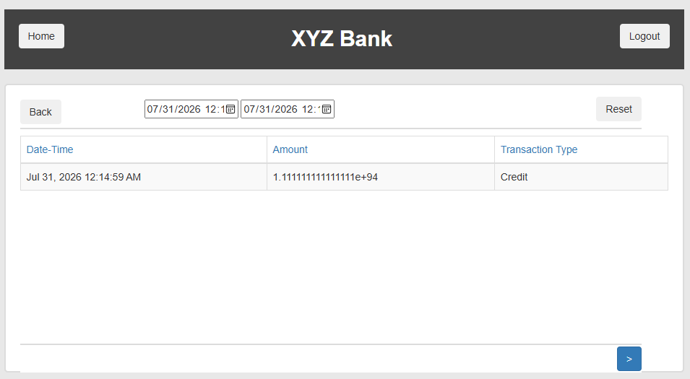
Evidence 1

IMP-05 | The success message has Red font like warning message
SEVERITY LOW | VALIDATION Observed during exploratory testing; evidence retained in this report.

Description: The sucess meessage font is similar to warning message which may confuse the user about the staus of teh transcion
Business impact: A success message styled like an error can make users think a completed transaction failed, encouraging duplicate attempts.
Steps to reproduce
- Log in as any customer and open the account page.
- Click Logout.
- Use the browser Back button.
- Observe whether the previously authenticated page or customer data is displayed.
- Attempt to interact with the page and verify whether access remains available.
Expected result: Success feedback should use a visually distinct success treatment, such as green text or a success icon.
Actual result: Success feedback uses red text that visually resembles an error or warning.
Application link: https://www.globalsqa.com/angularJs-protractor/BankingProject/#/login

